Unit 6 | Assignment – What’s the Weather Like?

# Observations

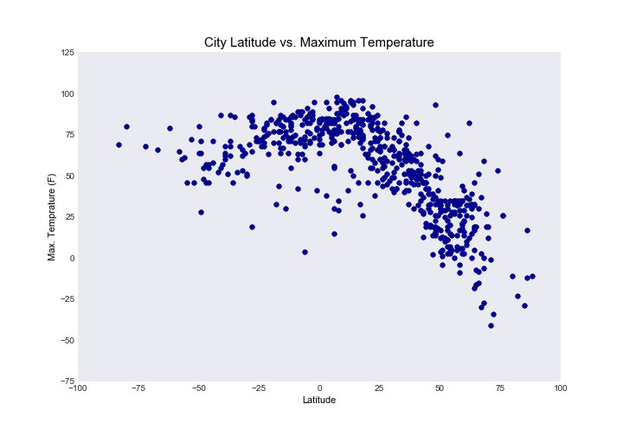

**Figure 1**

As we can evidently observe in Figure 1, temperature tends to gradually increase as the latitude value closes to 0 degrees which is the equator and further gradually decreases as it moves towards the positive increase in the latitude value.

1. In the plot of City latitude vs. Humidity, we could observe that there were more variance in the humidity percentage closer to Equator as compared to other latitude values which mostly experienced higher percentages of humidity. (Ref. Figure 2)
2. For the wind speed as compared to latitude, the results were pretty consistent across the latitudes with variance in the speed. Most of the cities experienced lower wind speed in range of 5 to 15 mph and few experienced higher speed. (Ref. Figure 3)

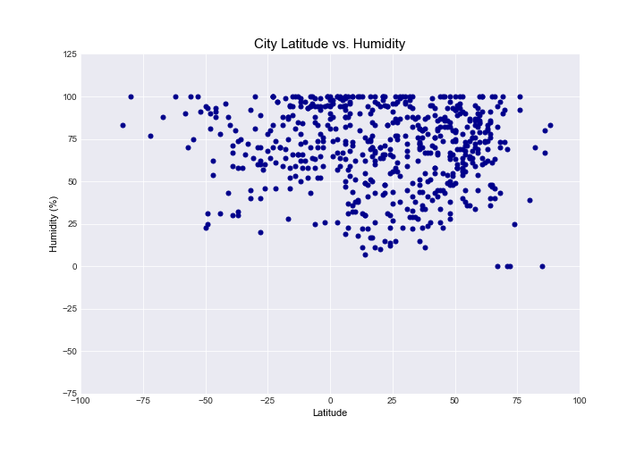

**Figure 2**

**Figure 3**

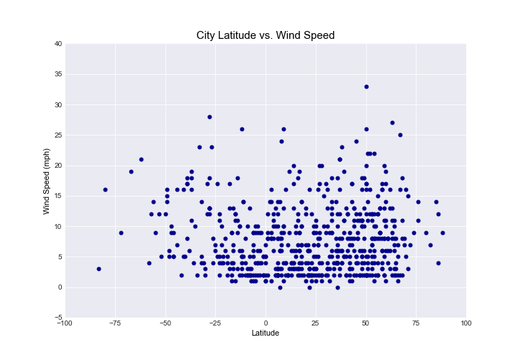

**Figure 3**